Cloud PLC library installation user manual

Library link: <https://drive.google.com/drive/folders/1XOH1eyiFR1nSGULIkSJUe-0BGHGhwnkV?usp=drive_link>

Copy the above link and paste into your browser

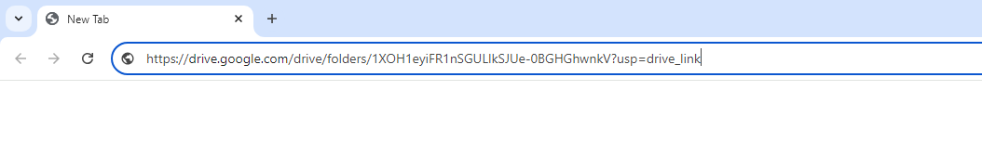

You will reach the drive folder, where you can click on 'Download All'. The Cloud PLC libraries ZIP file will then be ready for installation.

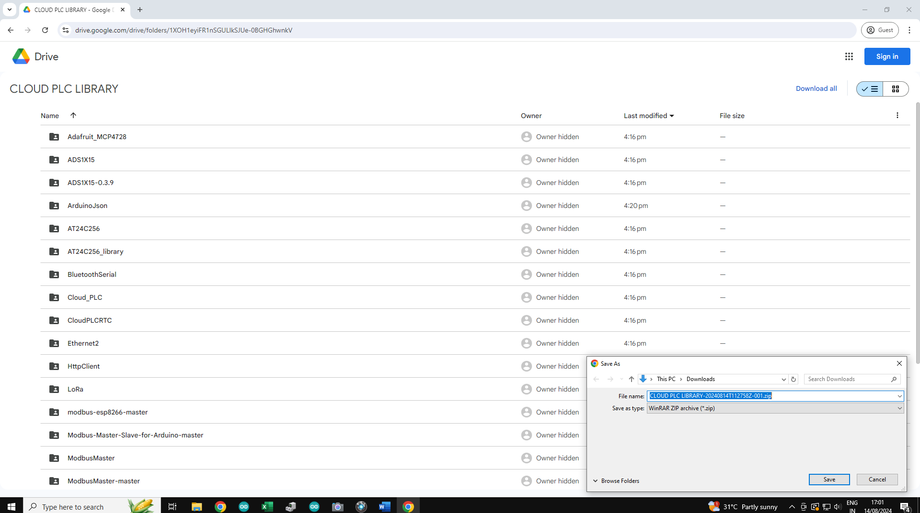

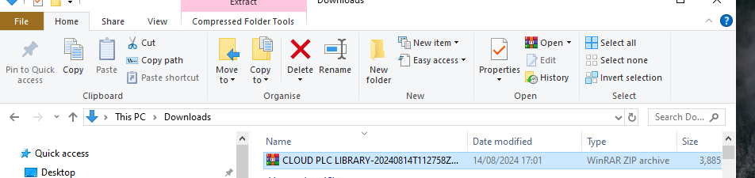

Locate the CLOUD PLC LIBRARY ZIP file, right-click on it, and select 'Extract All' to unzip the file.

Navigate the extracted folder and copy all the library file

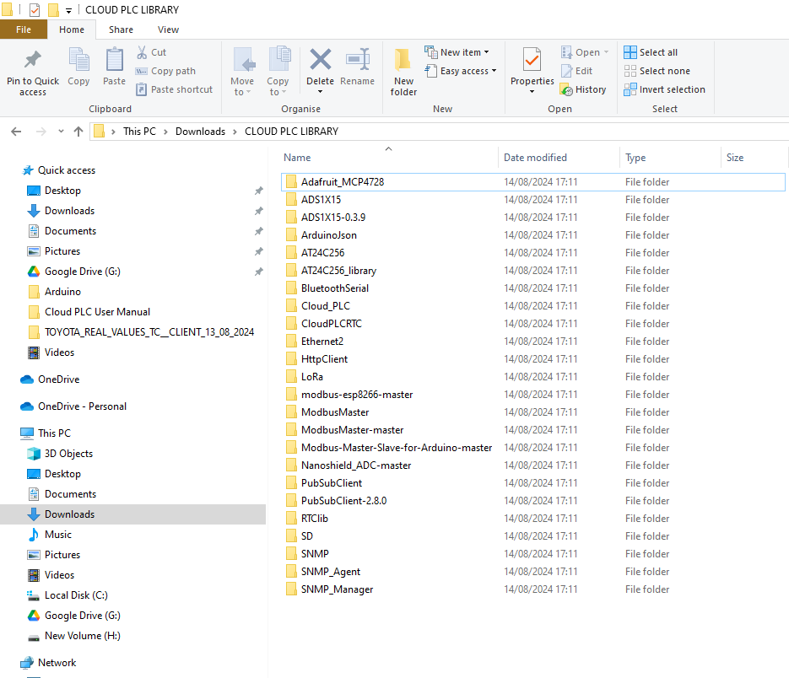

Click on 'This PC', then go to 'Documents', click on the 'Arduino' folder, and then open the 'libraries' folder.



* Paste it Here.

